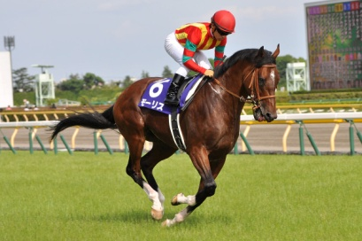
At the Races Maths Challenge
Task 1:
- Step 1 – Choose a horse
- Step 2 – Complete 2 races
1st Race Horse Number ____________
2nd Race Horse Number ____________

Results Race 1 Results Race 2

Task 2:
Find the probability of the following:
- Scoring 2
- Scoring 3
- Scoring 4
- Scoring 5
- Scoring 6
- Scoring 7
- Scoring 8
- Scoring 9
- Scoring 10
- Scoring 11
- Scoring 12

This is a way of recording the scores when rolling two dice called a sample space diagram.
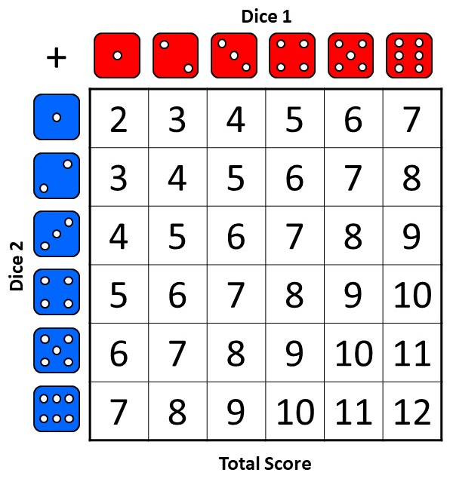

HINT Number of outcomes wanted
Total number of outcomes

Task 3:
Fill in missing words on the probability scale.

Unlikely Certain Impossible Likely Evens

Now place the letters from Task 2 on the scale in the correct place.
HINT : ½ = 18/36 = 0.5

GOLD CUP Race

3rd Race Horse Number ____________
Results Race 3
HINT:
Use Task 2 and Task 3 to help you

Give a reason for your choice in the final race.
I chose this horse because…

