**When a Candle is Alight**

**Task**

Draw a poster to explain what changes occur when a candle is lit. Use the top tips and belt ladder to help you reach your target.

**Melting and burning are identified as two different processes.**

**Some indication of the reversibility of change.**

**Used appropriate words correctly.**

**Made a comparison between physical and chemical change.**

**Simple definitions of physical and chemical change may be used.**

**Reasonably accurate particle diagrams to show melting.**

**Particle diagram for melting must have the correct particle arrangements for a solid and liquid.**

**Hydrogen, carbon and oxygen need to be identified as particles to illustrate chemical change.**

**Word equation included.**

**Belt** **Ladder**

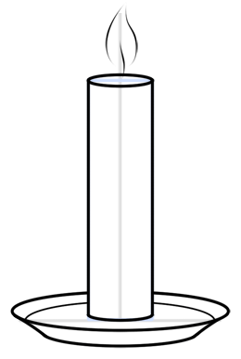

**Key Words**

Burning, chemical change, condensation, evaporation, fuel, gas, liquid, melting, physical change, solid, solidify, wax

**Top Tips**

* Draw the candle like the on above.
* Label where there is a change of state happening and where there is a chemical reaction happening.
* Write down the differences between a physical and chemical change.
* Draw particle diagrams to show the changes of state.