The Five Ws Challenge

What has happened? Where is it?

When did it happen? 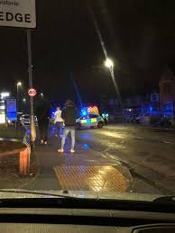 Who is involved?
Why did it happen?

Extension Tasks
If you were writing a newspaper article – what would the heading be?
Write an opening paragraph to link to your five Ws.

